**Superior University (Gold Campus)**





Task 1

**Submitted by:** Iqra Khawar

**Submitted to:** Sir Rasikh Ali

**Section:** 5B

**Semester:** 5th

**Deadline:** 21-09-2024

**Course:** Computer Network Lab

**Roll no:** su92-bssem-f22-307

**Department of Software Engineering**

Table of Contents

Installation of Cisco packet tracer 3

Visit the computer networking notes 3

Installation 3

View software 4

Router 4

Difference between all the routers and when to use them (mentioned in cisco packet tracer). 4

Switches 6

Difference between all the switches and when to use them (mentioned in cisco packet tracer). 6

Wires 7

Difference between all the wires and when to use them (mentioned in cisco packet tracer). 7

# Installation of Cisco packet tracer

## Visit the computer networking notes

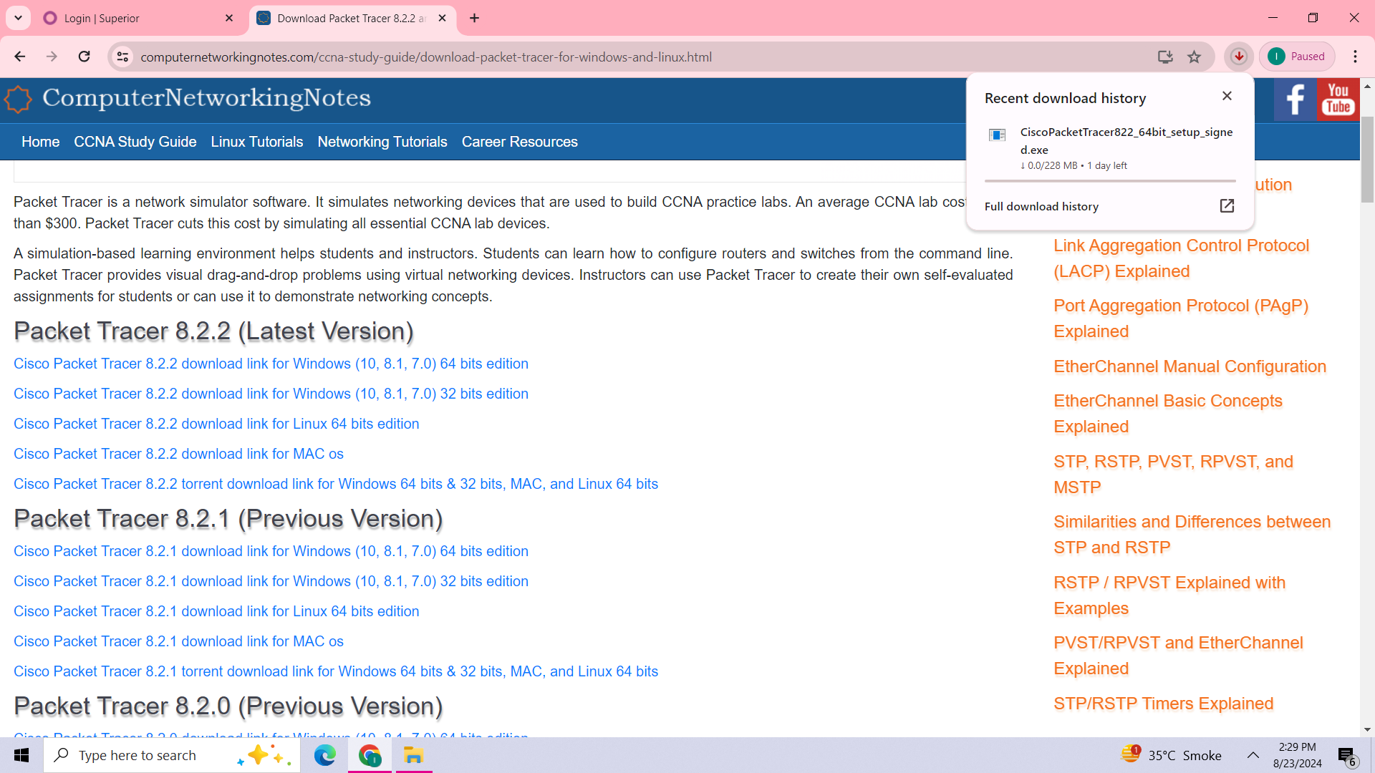

Click the latest version of cisco packet tracer and start downloading.

## Installation

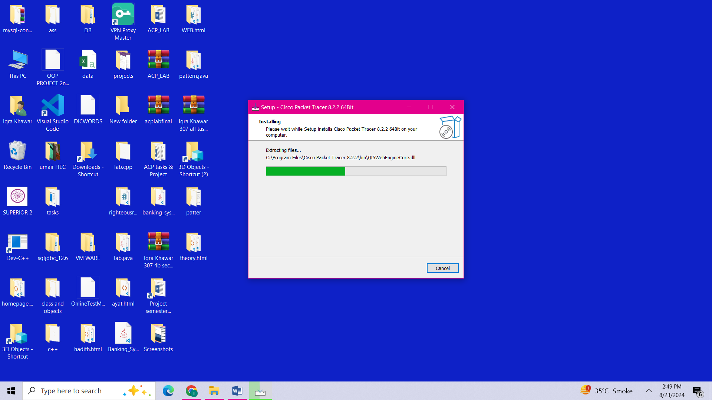

## View software

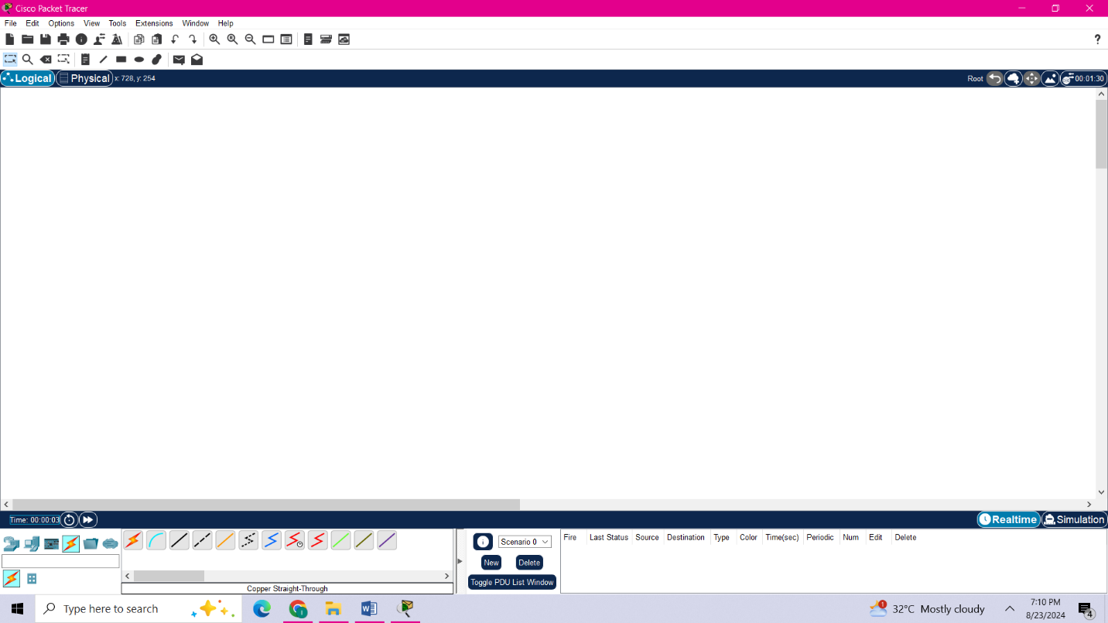

# Router

## Difference between all the routers and when to use them (mentioned in cisco packet tracer).

**ISR4331 router**

It is ISR (Integrated Service Provider). It provides 100 mbps to 300 mbps for managing throughput.

It provides one enhanced service module (enhanced service module is technology which has advanced features & functionality).

**ISR4321 router**

It provides 50 mbps for managing throughput.

**1941 router**

It delivers highly secure data, mobility & application services.

**2811 router**

It is used for WAN services, means to say WAN interfaces are used to connect different types of network. The 2811 router can handle multiple types of WAN network such as T1, E1 & x DSL.

**2901**

It allows more moderate performance and are suitable for medium sized branches e.g offices.

**2911**

The Cisco 2911 Integrated Services Router (ISR) delivers highly secure data, voice, video, and application services for small offices.

**2621 XM**

It is used for LAN services, means it provides two flexible Ethernet ports to connect LAN.

(Flexibility means ability of network that we can changes demands in it. i.e; configuration or technologies.)

**2620 XM**

It used for LAN & WAN purposes.

It is used for voice and data solutions.

(Voice over VOIP stands for ‘Voice Over Internet Protocol’ means to managing phone calls through network or internet.)

(Data solution means 2620 router to transfer data with high speed)

**PT (packet Tracer) Empty router**

It is a virtual router, It means that it start with no configuration and need to be setup from scratch.

**1841 router**

It is basically used for sending secure data connectivity.

**Router-PT**

It is packet tracer router used in cisco packet simulation. It sends & receives data on computer network.

**CGR1240**

It is basically design for demanding environments specialized in Field Area Network & Power distribution grids.

**829 router**

It is ruggedized & cisco IOS software. It is used for wireless LAN & WAN.

(Ruggedized router means a router built for harsh environment like rain & extreme **temperature.)**

**819 HGW**

It is also ruggedized. HGW stands for Home Gateway. It used for in offices, school purposes or in small area.

**819 HG-4G-IOX**

It is available for reliable & rugged connectivity solutions. 4G means it supports 4G LTE connectivity & IOX means it provides supports for edge computing & applications.

# Switches

## Difference between all the switches and when to use them (mentioned in cisco packet tracer).

**2960 24TT**

It is fixed configuration switch, that provide desktop Fast Ethernet connectivity for entry-level wiring closet and small branch-office networks.

**Switch-PT**

A switch connects devices within a LAN by using MAC addresses to identify where to send data packets. The server connect to switch and all end user devices connect to switch.

**Switch PT empty**

It is a virtual switch with no pre-configurations, it need to setup from start.

**3560 24PS**

This switch is used for LAN purposes. It is not stackable witch means to say you can’t join several switches over GBPS links.

**3650 24PS**

It is stackable witch means to say you can join several switches over redundant 120 GBPS links & and manage one by one.

**IE-2000**

It is available for ruggedized access that handle security & voice purposes.

**PT-Bridge**

It is used to interconnect two or more LAN and sends packets between this network.

**2950-24**

It is a 24 port Ethernet networking switch. It provides fast Ethernet connectivity all over the ports.

**2950T**

It is a fixed configuration, standalone switch that provides wire-speed Fast Ethernet and Gigabit Ethernet connectivity for midsized networks.

# Wires

## Difference between all the wires and when to use them (mentioned in cisco packet tracer).

**Automatic choose connection type:**

It is basically the auto connector wire used for connection between routers & between switches.

**Console**

It is also known as roll over cable used for connecting computer terminals to routers.

**Copper straight through**

It used for connecting different devices.

**Copper crossover**

It is used for connecting same devices.

**Fiber**

It used for connecting WAN purposes.

**Phone**

This wire is used for managing phone calls over VOIP. (Voice Over Internet Protocol)

**Co-axial**

This is also used for connecting WAN purposes.

**Octal**

This cable you will need to connect to your console ports from a Cisco 2509 or 2511 router.

**IOT custom cable**

It is used to connect IOT devices.

**USB**

This cable is used for connecting devices to computers.